Q1. What is software? What is software engineering?

Ans. **software**, instructions that tell a computer what to do. Software [comprises](https://www.merriam-webster.com/dictionary/comprises) the entire set of programs, procedures, and routines associated with the operation of a [computer system](https://www.britannica.com/technology/computer). The term was coined to [differentiate](https://www.merriam-webster.com/dictionary/differentiate) these instructions from [hardware](https://www.britannica.com/technology/hardware-computing)—i.e., the physical components of a computer system. A set of instructions that directs a computer’s hardware to perform a task is called a program, or software program.

The term **software engineering** is the product of two words, **software**, and **engineering**.

The software is a collection of integrated programs.

Software subsists of carefully-organized instructions and code written by developers on any of various particular computer languages.

Computer programs and related documentation such as requirements, design models and user manuals.

Engineering is the application of scientific and practical knowledge to invent, design, build, maintain, and improve frameworks, processes, etc.

**Software Engineering** is an engineering branch related to the evolution of software product using well-defined scientific principles, techniques, and procedures. The result of software engineering is an effective and reliable software product.

Q 2. Explain types of software

Ans. Software's are broadly classified into two types, i.e., System Software and Application Software.

1. System Software

System software is a computer program that helps the user to run computer hardware or software and manages the interaction between them. Essentially, it is software that constantly runs in the computer background, maintaining the computer hardware and computer's basic functionalities, including the operating system, utility software, and interface. In simple terms, you can say that the system acts as a middle man that checks and facilitates the operations flowing between the user and the computer hardware.

System software is not limited to the operating system. They also include the basic I/O system procedures, the boot program, assembler, computer device driver, etc. This software supports a high-speed platform to provide effective software for the other applications to work in effortlessly. Therefore system software is an essential part of your computer system. They are the first thing that gets loaded in the system's memory wherever you turn on your computer. System software is also known as "low-level software" because the end-users do not operate them. Companies usually employ the best software development programmers who can deploy efficient system software.

The further classifications of system software are as follows:

1. Operating System

The operating system is the most prominent example of system software that acts as an interface between the user and system hardware. It is a group of software that handles the execution of programs and offers general services for the application that runs over the computer. There are various types of operating systems available in the market, such as embedded operating systems, real-time OS, distributed OS, single or multi-user operating system, mobile, Internet, and various others.

Q 3 .What is SDLC? Explain each phase of SDLC

Ans. Software Development Life Cycle (SDLC) is a framework that defines the steps involved in the development of software at each phase. It covers the detailed plan for building, deploying and maintaining the software.

SDLC defines the complete cycle of development i.e. all the tasks involved in planning, creating, testing, and deploying a Software Product.

[SDLC Phases](https://www.softwaretestinghelp.com/software-development-life-cycle-sdlc/#SDLC_Phases)

* + [Requirement Gathering and Analysis](https://www.softwaretestinghelp.com/software-development-life-cycle-sdlc/#1_Requirement_Gathering_and_Analysis)
  + [Design](https://www.softwaretestinghelp.com/software-development-life-cycle-sdlc/#2_Design)
  + [Implementation or Coding](https://www.softwaretestinghelp.com/software-development-life-cycle-sdlc/#3_Implementation_or_Coding)
  + [Testing](https://www.softwaretestinghelp.com/software-development-life-cycle-sdlc/#4_Testing)
  + [Deployment](https://www.softwaretestinghelp.com/software-development-life-cycle-sdlc/#5_Deployment)
  + [Maintenance](https://www.softwaretestinghelp.com/software-development-life-cycle-sdlc/#6_Maintenance)

Q 4.What is DFD? Create a DFD diagram on Flipkart

Ans. **DFD** is the abbreviation for **Data Flow Diagram**. The flow of data of a system or a process is represented by DFD. It also gives insight into the inputs and outputs of each entity and the process itself. DFD does not have control flow and no loops or decision rules are present. Specific operations depending on the type of data can be explained by a flowchart.

It is a graphical tool, useful for communicating with users ,managers and other personnel. it is useful for analysing existing as well as proposed system.

It provides an overview of

* What data is system processes.
* What transformation are performed.
* What data are stored.
* What results are produced , etc.

DFD Diagram :

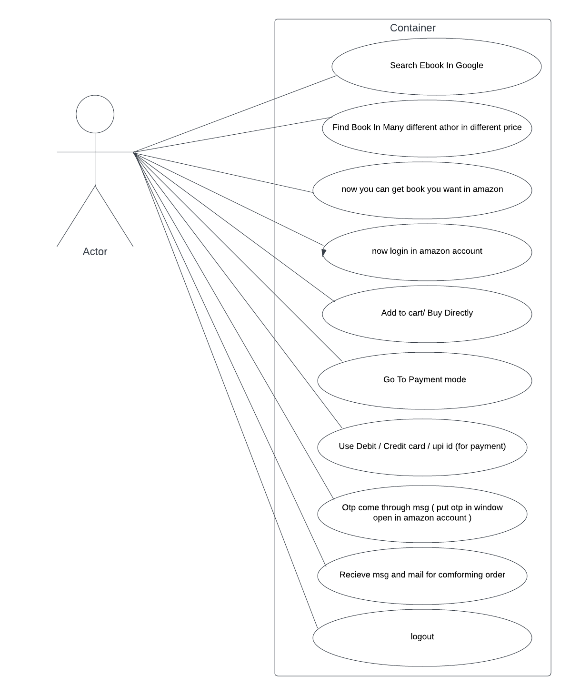

Q5. What is Flow chart? Create a flowchart to make addition of two numbers .

Ans. Flowcharts are nothing but the graphical representation of the data or the algorithm for a better understanding of the code visually. It displays step-by-step solutions to a problem, algorithm, or process. It is a pictorial way of representing steps that are preferred by most beginner-level programmers to understand algorithms of computer science, thus it contributes to troubleshooting the issues in the algorithm. A flowchart is a picture of boxes that indicates the process flow in a sequential manner. Since a flowchart is a pictorial representation of a process or algorithm, it’s easy to interpret and understand the process. To draw a flowchart, certain rules need to be followed which are followed by all professionals to draw a flowchart and is widely accepted all over the countries.

flowchart

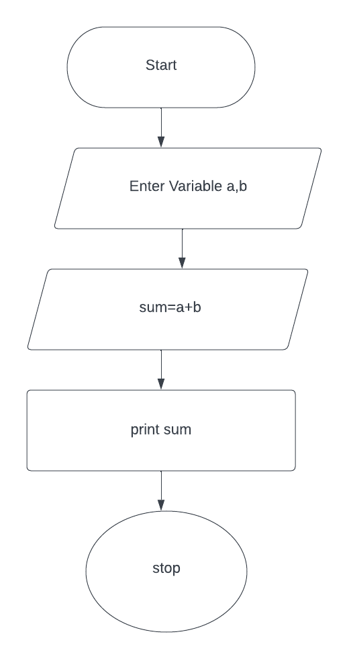

Q6. What is Use case Diagram? Create a use-case on bill payment on paytm.

Ans. A use case diagram is a way to summarize details of a system and the users within that system. It is generally shown as a graphic depiction of interactions among different elements in a system. Use case diagrams will specify the events in a system and how those events flow, however, use case diagram does not describe how those events are implemented. A [use case](https://www.techtarget.com/searchsoftwarequality/definition/use-case) is a methodology used in system analysis to identify, clarify, and organize system requirements. In this context, the term "system" refers to something being developed or operated, such as a mail-order product sales and service [Web site](https://www.techtarget.com/whatis/definition/Web-site). Use case diagrams are employed in [UML](https://www.techtarget.com/searchsoftwarequality/definition/Unified-Modeling-Language) (Unified Modeling Language), a standard notation for the modeling of real-world objects and systems. There are [a number of benefits](https://www.techtarget.com/searchsoftwarequality/news/1273406/The-pros-and-cons-of-use-case-diagrams) with having a use case diagram over similar diagrams such as flowcharts.

Create a use-case on bill payment on paytm.

